DEBATE ABOUT MEANING OF THE PICTURE ON ONION

OUR THOUGHTS ABOUT SYMBOLIC MEANINGS OF COLLAGE
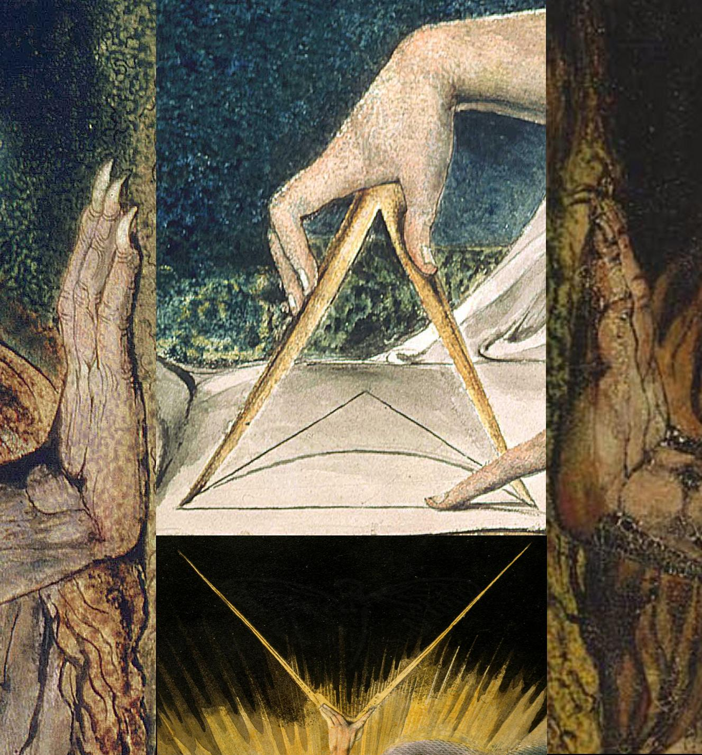

if you look closer to the image, there is the cicada symbol
Onion 1 HTML Source
<html><head><title>For Every Thing That Lives Is Holy</title><body><img src="1033.jpg" /></body></html>

ORIGINAL FILE:
http://oi42.tinypic.com/15s0nly.jpg
EXIF (empty like at every image with outgueess):
http://regex.info/exif.cgi?dummy=on&imgurl=http%3A%2F%2Foi42.tinypic.com%2F15s0nly.jpg

HANDS ARE FROM:
https://en.wikipedia.org/wiki/File:William_Blake_-_Nebuchadnezzar_%28MFA_Boston%29.jpg
https://en.wikipedia.org/wiki/File:William_Blake_-_Nebuchadnezzar_%28Tate_Britain%29.jpg
https://en.wikipedia.org/wiki/File:William_Blake_-_Nebuchadnezzar_%28Minneapolis%29.jpg
https://en.wikipedia.org/wiki/Nebuchadnezzar_%28Blake%29
Exact source: http://khalatnost.files.wordpress.com/2009/10/nebuchadnezzar-tate-collection.jpg

TOP NEWTON TRIANGLE IS FROM
Newton is a monotype by the English poet, painter and printmaker William Blake first completed in 1795,[1] but reworked and reprinted in 1805.[2] It is one of the 12 "Large Colour Prints" or "Large Colour Printed Drawings" created between 1795 and 1805, which also include his series of images on the biblical ruler Nebuchadnezzar.
https://en.wikipedia.org/wiki/Newton_%28Blake%29

This is exact source:
- 4,702 × 3,617 pixels
- picture was used in colage in same resolution than original, no rezizing, just cropping
- but it was mirrored

Bottom Ancient Days is from
This is name of picture and its page on wiki but none of those fit our source:
- http://en.wikipedia.org/wiki/The_Ancient_of_Days
This is article where original source is from:
- http://en.wikipedia.org/wiki/His_Dark_Materials
- The_Ancient_of_Days This is exact image
This is exact source:
- 2,057 × 2,800 pixels
Image used in colage is:
- Rescaled on 46,5% exactly horizontally and vertically
- Resolution of original is 2,057 × 2,800 pixels

Superimposed Cicada on Ancient Days
Looks like standard logo 3301 uses. We dont have the exact source of Cicada logo. People belive that it's source is some old zoology book, but that rumor was never proven with any link.
The image on the collage looks slightly enlarged.
And horizontaly MIRRORED! (this is first time 3301 used mirrored logo. Note that Ancient days on which logo is superimposed is not mirrored but rotaed for 180°)
Best resolution logos we have are one from png XORed in 2013 and one that was used on CICADA OS for abkground in Format LSS 16
$ file mnt/boot/isolinux/splash.rle
mnt/boot/isolinux/splash.rle: SYSLINUX' LSS16 image data, width 640, height 300
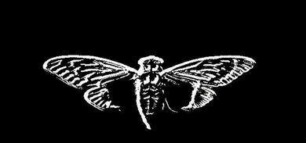
Splasgh screen from Cicada OS in LSS16 format


outt.png we XORed in 2013 twitter XOR mp3 XOR 560.13 = base64 of png

Artefact on place where Newtons finger points.
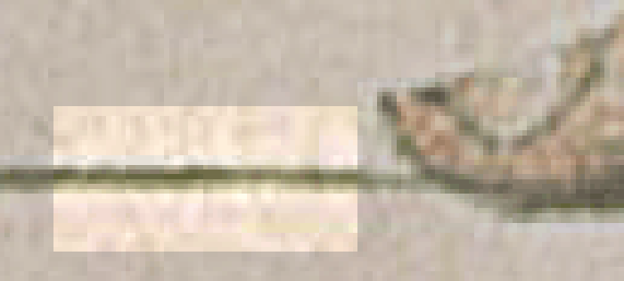

. Animated gif showing difference on 1033.jpg and source from wikipedia
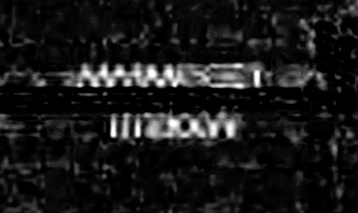
the upside down text.
http://chosenhalfblood.blogspot.com/2014/01/jpg-artifacts-in-newton-by-blake.html

Lurkers anylysis.
Collapse
Excerpts from log, explaining few obsertions about 1033.jpg
<Lurker69> it could be intentonal or it could be misclick of guy who made colage
<Lurker69> colage is very unprofessionaly done
<Lurker69> on bottom right corner, hand image doesnt cover whole jpg, 2 pixels too short...
<Lurker69> you can see parts of image that was on background layer
<Lurker69> no idea what image on background was, looks very dark, i hanet find exact pixles from source images yet
<Lurker69> and middle parts of colage are not aligned correctly, offset by couple of piyels
<Lurker69> also bottom picture has some sort of 2 pixel frame around it with some filter sice ti is more visibble in bottm left than in top right
<Lgx> so my question is.. IF we found the image of the newton in its original bits... meaning the code matched up perfectly.. we c oudl then decipher what was added and extract it .. or am i missing the point? does it change entirely..
<Eve57> Did we look for preview images in all JPEGs? I saw JPEGsnoops of the early images but not of all.
<GenPop44> would the code change if the entire image is mirrored to get the cicada in it normal position?
<BlueFox> you can't do that
<BlueFox> well I'm sure you could, but it'd be very difficult
<Lgx> so we take the image... change it into its code .. wahtever that may be.. similiar to how we got our three images... jsut reverse process....
<Lgx> then find the newton in that image and compare it to another picture.. try to find the same code....
<[diogenesapophen> Eve57: there have been no thumbnails
<Lgx> i think..
<Lgx> oh yea
<Eve57> Okay, then I can spare the effort, thx!
<Eve57> 07:17 ... maybe time for bed?
<[diogenesapophen> Lurker69: i thought collage image look reallly shit, too
<[diogenesapophen> Eve57: y bother at that time ^_^
<[diogenesapophen> other img they have use look much better
<[diogenesapophen> i wonder if diff person do editing
<Eve57> I will. I wanted to wait until the scan completes but it took 3...4 hours to process 20 MiB and still 269 MiB to go. What the heck is so slow?
<rockymountain> it's slow for me too
<Lurker69> [diogenesapophen: yes i think so too
<Eve57> What are you trying, rockymountain?
<Lurker69> pages of book were made by professionla editor, i mean somebody that have set a book or two for printing before
<Lurker69> that 1033.jog was done by somebody with 2 hours of image editing experience
<[diogenesapophen> maybe made in a hurry
<Eve57> Well, thinking about it this way...
<Eve57> The server-status images - pages 5 and 6 - were not made in a hurry...so it was either intended or they changed the plan.
<Lurker69> all pages from book were not made in a hurry
<Lurker69> aonly 1033, cover of boo?, that has also difernt dimmensions is done sloppy
<Lurker69> book pages are 2400x3600 1,5 ratio
<Eve57> If we stick with our assumption that server-status was not intended...maybe they are still recovering and changing the plan.
<Lurker69> 1033.jpg from onion 1 is 1327x1427 ratio is 1.07535795026 very nonstandarsd ratio
<azzy23> Or maybe they've ended this year early. Hrm.
<azzy23> I don't think so. I think the server status was leaked on purpose.
<Lurker69> i dont think it was done in a hurry, everyone with slightes experience in image ediitng wouuld od colage with less mistakes in no time
<Lurker69> i will make infograpihcs with all mistakes....

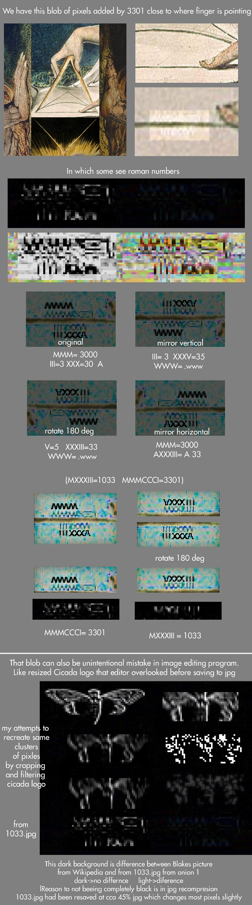

SOME CHAT LOG EXCERPTS
[14:42] <GenPop44> might be something. Newton in onion on is holding a Golden Compass. = 619 prime based upon a book "northern lights" by philip pullman. lots of Uriel, blake influence.
[14:42] <gonflynn> mass, i find that a strange coincidencee
<NEM0> this is the difference between original and our blake.jpg @400% zoom http://prntscr.com/2k19rz
<NEM0> @1000% http://prntscr.com/2k1a5o
[12:08] <stagnantcluelack> is it just me or does the collage look a little bit like a thelema star? Crowley_unicursal_hexagram.svg/500px-Crowley_unicursal_hexagram.svg.png
12:45] <typhoid> its not a pyramid
[12:45] <typhoid> its not the thelema star
[12:45] <typhoid>Masonic_SquareCompassesG.svg/456px-Masonic_SquareCompassesG.svg.png
from #cicadasolvers 15/1/2014 0536 GMT
[06:36] <azzy23> In the square & compass symbol, there is a G in the middle. The G is a Ghemel, which is representative of god, and carries the numeric value of 3
[06:36] <azzy23> both of the Blake hands are holding a compass.
[06:37] <azzy23> The one on top comes from a painting of Newton, the one on bottom is god... science above faith.
[06:37] <azzy23> The hands on the sides are from the painting Nebechenezzur, which represents the fall into man's bestial nature
[06:37] <cydoniac> Where are you seeing that symbol?
[06:37] <BlueFox> yes, they are, but if you overlay onto the matrix page, the finger points somewhere, no?
[06:37] <azzy23> http://www.masonic-lodge-of-education.com/square-and-compasses.html
[06:37] <TaiiwoBot> ^ SQUARE AND COMPASSES - Freemasonry's Logo http://tinyurl.com/pqw9j3q ^
[06:38] <azzy23> if you take the Blake painting into paint or something, draw in the lines
[06:38] <L4T1V3> yeah the second line
[06:38] <azzy23> it looks like the square & compass, sans the G
[06:38] <azzy23> the finger is pointing to the middle, where the G would be
[06:38] <azzy23> and the G represents the number 3, in numerology
[06:38] <azzy23> (it's god, and god is always 3)

PICTURES

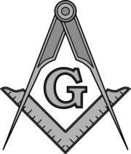
Masonic SquareCompasses Crowley_unicursal_hexagram THELEMA


Page bibliographique de Pierre Thuillier-Dateien/Thuillier02
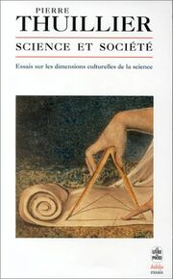
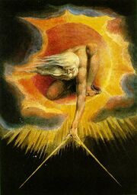
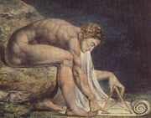

== PIC ==

CLUES WITHIN ONION 1 IMAGE

Clear explication of the Newton Blake "JPG Artifacts":

http://chosenhalfblood.blogspot.com/2014/01/jpg-artifacts-in-newton-by-blake.html

Newton-WilliamBlake.jpg ARTEFACT
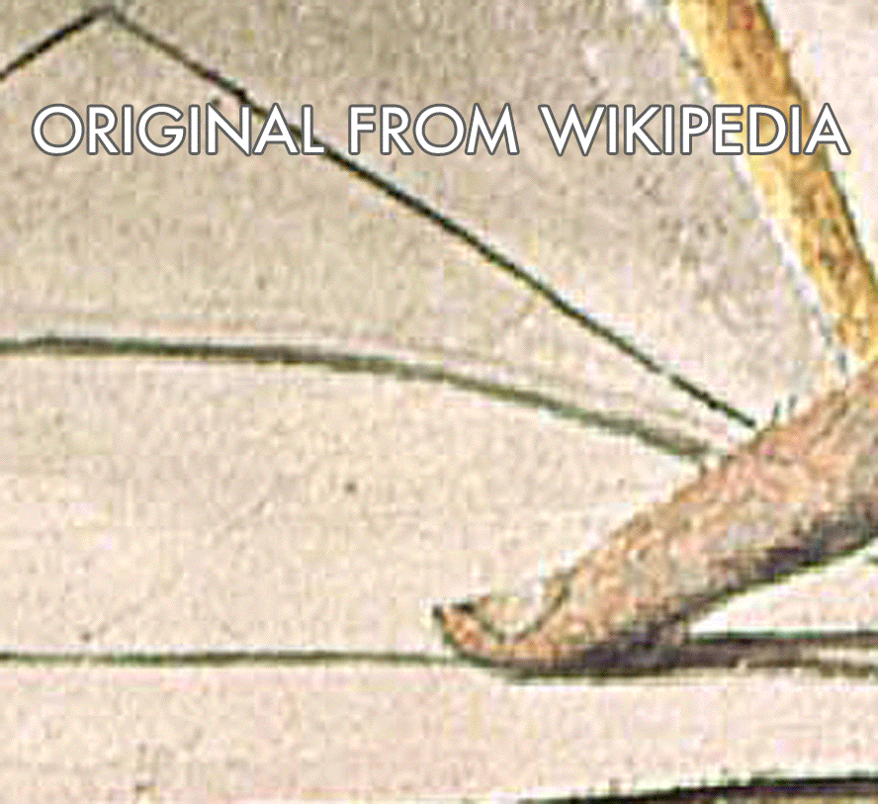

[23:00:57] <onecool> anyone see this clue in the image? http://i.imgur.com/HNKXdXo.jpg

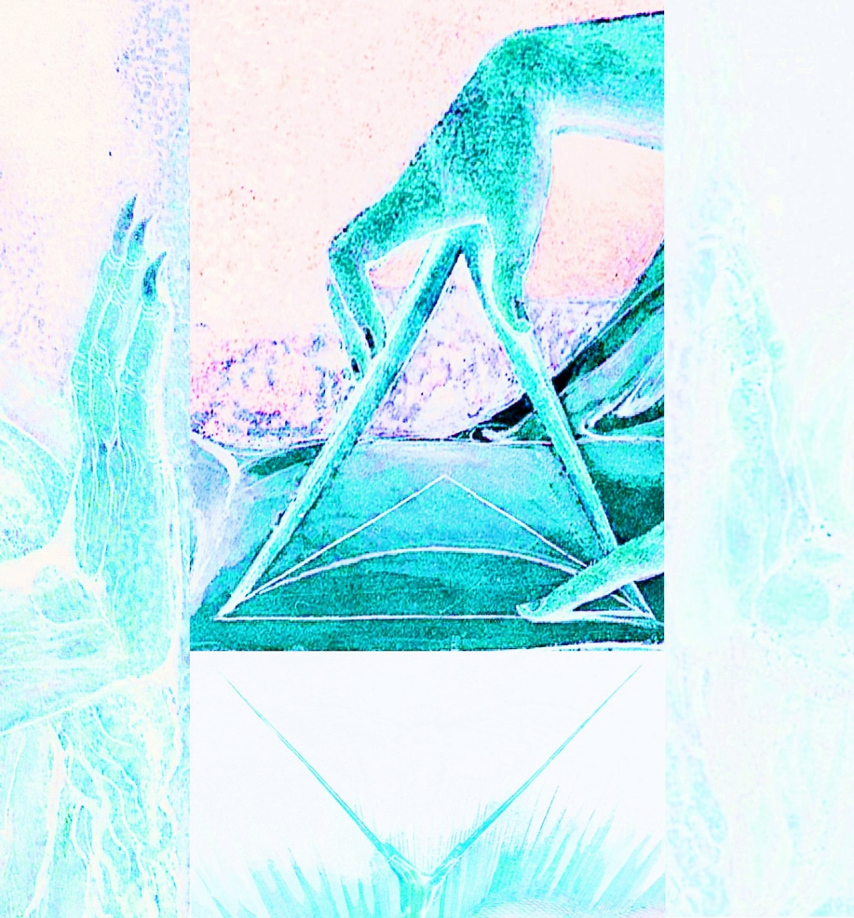

SOME MORE INFO HERE:
http://uncovering-cicada.wikia.com/wiki/2014_CICADA_3301_DATA_DUMP
NEEDT TO BE COPIED O NTHIS PAGE
THIS PAGE NEEDS TO BE EDITED TO LOOK NICE (IF YOU DO THAT DONT DELETE ANY OF PICS AND LNKS JUST RECATEGORIZE THEM

POSSIBLE CLUE 1

A possible clue was found within the image. It appears to be upside down text. If you rotate the image you get the following:
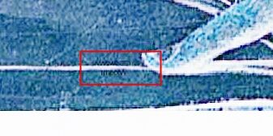
Text seems to appear where the finger is pointing
ALL RELATED:
http://gyazo.com/d92c9999e6e2cc62b4a2025bcc01cf72
http://i.imgur.com/pGl8T7k.png
http://imgur.com/fhKoXqR
http://i.imgur.com/kyoaVG2.png
http://i.imgur.com/159kitn.jpg
http://imgur.com/xFHyW28
http://prntscr.com/2h4xnz
http://i.imgur.com/HHP5yn6.png http://prntscr.com/2hezte

A zoomed in image is as follows:
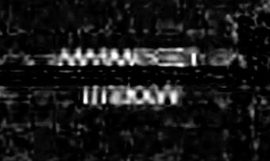
the upside down text.

Further Proof it is actual text on the picture rather "jpeg artifacts"
After inspecting 10+ pictures online it seems as if the picture they used originally to edit/crop was the picture from wikipedia: http://en.wikipedia.org/wiki/File:Newton-WilliamBlake.jpg
Colors match up, size match up (perfectly overlay)
But also after overlaying them perfectly and applying the difference option in layer settings you clearly see this:
Cropped: http://i.imgur.com/P6Bg828.jpg
Same image , zoom in, inverted colors, levels up http://prntscr.com/2inz9k

Also after zooming in and having both layers in normal mode and making a gif turning on and off the top layer you can clearly see it is not just jpg artifact but definate lines. and shapes in a white color font: *Red text added so you know which version(s) you are seeing.
http://gyazo.com/d92c9999e6e2cc62b4a2025bcc01cf72
Top line: MMMCCCI (or 3301) <- Assumptions
Bottom line (rotated 180 degrees): MXXXIII (or 1033) <- Assumptions

POSSIBLE EXPLANATIONS

MXXXIII
ue.1033.www
<doodleninja> http://www.3301.eu/
<doodleninja> umm
<doodleninja> its ue.1033.www
<doodleninja> backwards
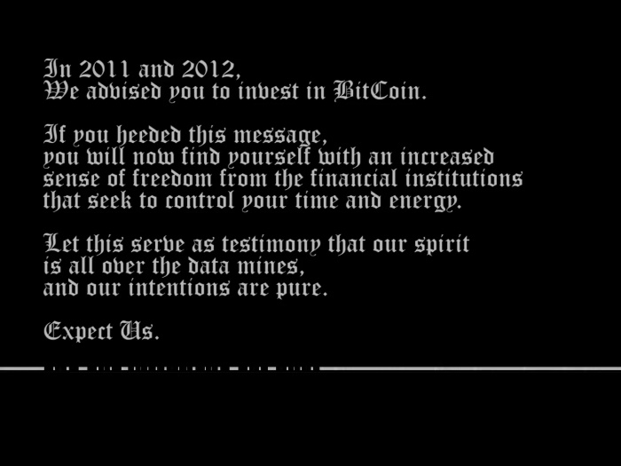

MORE
Hi,
the embedded Roman/Latin numbers in the image are 1033 in Arab. The website www.3301.eu is *definitively* a dead end - I checked it! Therefore, it could have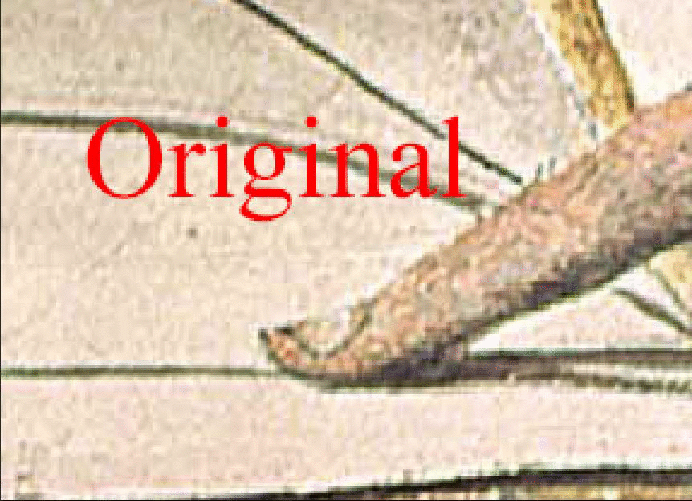

MORE
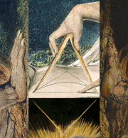
Gif showing fibonachi phi reatio between dark and white part of image
looks like cicada is tunneling to the surface...

MISTAKES AT COLLAGE
IT seems that image has few minor technical mistakes. All 4 parts of image are not touching and widths are not aligned perfectly.
